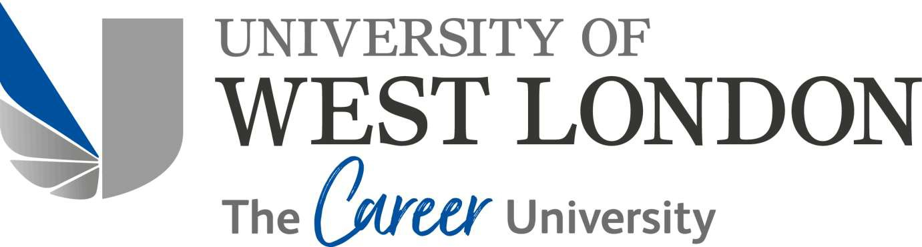

Graduate Internship Programme - Employer Job Description

Job title | Graduate Marketing Project Coordinator (TSRE)
Organisation | Timo Seks Real Estate UK Ltd
Line manager who the intern will report to | Simon Tim Muwanguzi, Founder & Managing Director
Is this role hybrid working or  permanently onsite at your company? | Hybrid working in the short-term and permanently onsite in the long-term
Collaborate with the Company Directors to execute Sales and Marketing Campaigns for brand building and lead generation with overall company goals and sales targets.

Please provide a one-sentence description for advertising the role on the GI website
The aim of the internship is for the post holder to gain employability skills and experience of working in a professional working environment and an understanding of aspects of the business.

The main purpose of this role is to provide project, marketing, administrative and technical support to cover the duties of the graduate-level project (s) assigned by a line manager from Timo Seks Real Estate UK Ltd.

The post holder will be working within a team and will be expected to use their initiative and undertake self-directed learning within a supportive environment to develop their skills and gain a good working knowledge of Timo Seks Real Estate UK Ltd policies and procedures and of the wider University, to make a positive contribution to the team and Timo Seks Real Estate UK Ltd.
Graduate Interns will be supported throughout their internship with a programme of development and evaluation.
Main purpose of the job
To offer Mentorship opportunities to the right candidate. Our aim is to help you grow as a person and become the best version of yourself at a professional level. We will be fully committed to enable you to achieve your personal and career goals now and in the future.

To obtain valuable support as a Team player to the rest of the work colleagues. Our Top Priority is to enable you to settle in quickly so that you become and feel part of a productive Team. We are like - minded and positive individuals who are very determined to become so successful together.

To create a sense of community involvement in partnership with the University of West London. As a reputable university not only in West London but also nationally, it's our obligation as Alumni and interns respectively to work together to make our part of London a better place to work and live for our local community. For instance, we will provide suitable housing solutions to help local residents from being evicted from their homes by banks for defaulting on their mortgages.

To seek input from the intern whom we expect to join brainstorming sessions or meetings which will come in handy in terms of drawing up strategies, policies, plans, and sales forecasts to mention but a few.
To share our big vision with the right candidate so that he or she grows with our company and by doing so, all of us will not only build a successful business within the next 5 years but will also achieve our personal goals
respectively!
What you will gain from this internship

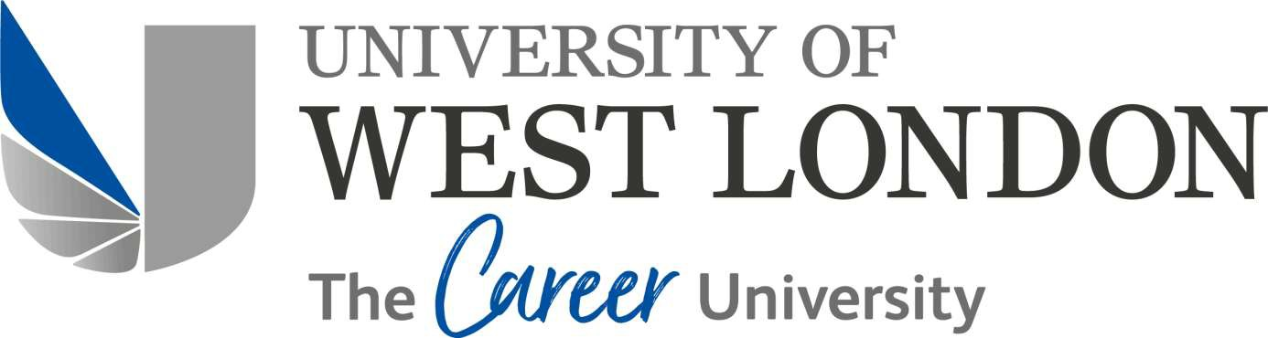

Market Research of our target audience PR & Marketing campaigns
Engaging with customers or clients Achieving Sales targets
Working as a part of a team in the company to achieve all our business and personal goals.

Key areas of responsibility

Sales & Marketing experience.
Property Sales, Lettings and Management experience (not compulsory). Market Research especially for Lead generation.
Excellent Customer service and interpersonal skills.
Highly motivated and very ambitious

Skills/knowledge required

Graduate must have completed an undergraduate degree, BA/BMus/BSc/BEng/LLB etc. and be from the summer graduating class of June/July 2023.
Recruitment criteria

Updated: Jan 2024

