Graduate Internship Programme – Job Description
Job title | Graduate Research Assistant for SCE
School / Department | School of Computing and Engineering
Line manager who the intern will report to | Dr Neda Azarmehr
Is this role hybrid working or permanently onsite at UWL? | Hybrid working

Please provide a one-sentence description for advertising the role on the GI website
Automated Detection of Perineural Invasion Using Digital Pathology Images

Main purpose of the job
The aim of the internship is for the post holder to gain employability skills and experience of working in a professional working environment and an understanding of aspects of the business.
The post is to provide support for ongoing research projects in the School of Computing and Engineering.
The post-holder will assist with the planning and coordination of research studies and will be involved in data collection, analysis, and support for some of the administrative aspects of the research e.g., preparation and distribution of research materials.
Graduate Interns will be supported throughout their internship with a programme of development and evaluation.

What you will gain from this internship
- Technical skills: You will practice various AI and machine learning techniques, and tools.
- Hands-on experience: You will have the opportunity to work on real-world projects and apply the concepts you have learned in a practical setting.
- Networking: You will have the opportunity to build connections with other interns, mentors, and professionals, which can help you in your future career.
- Problem-solving skills: You will learn how to analyse complex problems and develop solutions using AI and machine learning techniques.
- Communication skills: You will improve your communication skills by working with team members, presenting your work, and explaining technical concepts to non-technical stakeholders. Overall, this internship can provide you with a solid foundation in AI and machine learning, as well as the skills and experiences needed to succeed in the field.

Key areas of responsibility
- Data preprocessing: Preparing, cleaning, and transforming data to be used in Deep learning models.
- Model development: Building and testing deep learning models using various algorithms and techniques.
- Model evaluation: Evaluating the performance of models using various metrics and techniques.
- Research and development: Conducting research on new AI and machine learning techniques and experimenting with new approaches.
- Documentation: Creating documentation for machine learning models, code, and data preprocessing steps.
Overall, the key areas of responsibility involve working on projects related to data preprocessing, model development, model evaluation, and model deployment, as well as contributing to research and development efforts, collaborating with team members, and focusing on personal learning and growth.
Perineural Invasion (PNI) occurs in many cancers including head and neck cancer (HNC) and it refers to the invasion of cancer to the space surrounding a nerve. It is common in HNC, prostate cancer and colorectal cancer. If PNI is present it is a sign of tumour metastasis and the poor prognosis of patients. Moreover, the presence or absence of PNI could affect treatment decisions. Manual detection of PNI using WSI is a time-consuming and tedious task and the skills and expertise of a pathologist also play a key role in manual inspections. Less experienced pathologists may miss the presence of PNI resulting in diagnostic errors. In addition, it suffers from inter and intra-observer variability. This research aims to investigate the ability of deep learning algorithms to detect PNI in HNC using Whole Slide Images.
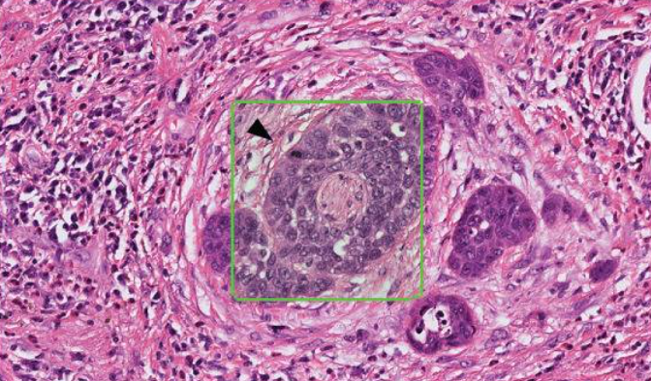
An example of PNI in oropharyngeal carcinoma (green box)

Skills/knowledge required
- Background in AI, ML, and DL
- Practical experience in programming in Python
Practical experience with one of the deep learning frameworks (e.g., TensorFlow, PyTorch)
Recruitment criteria
Graduate must have completed an undergraduate degree, BA/BMus/BSc/BEng/LLB etc. and be from the summer graduating class of June/July 2023.

Updated: Jan 2024

