Board of Governors
6 July 2021

Annual Report on Equality, Diversity and Inclusion

Summary
  - A report on Equality, Diversity and Inclusion is provided to the Board of Governors each year to provide assurance that the University is undertaking its duties under the Equality Act (2010). It is also intended to demonstrate the breadth and depth of the work that the University is taking to promote equality, diversity and inclusion for all. This report provides an update on the University’s action on equality, diversity and inclusion for the 2020-21 academic year.
  - The University is always looking to improve and to progress issues of equality, diversity and inclusion. The University is, however, justly proud of the progress it has made in championing equality, diversity and inclusion both internally and across the sector. The University has one of the most diverse staff across the sector with 35% ethnic minority staff with representation of ethnic minority staff at all levels. Indeed, we have ethnic minority representation on senior management and also the highest levels of ethnic minority and in particular Black professors in the UK. Female representation is also at all levels with a median gender pay gap of zero%. This success is also reflected in our student profile where we are very successful in improving access to under-represented group as 55% of students are from ethnic minority backgrounds, we have significant numbers of mature students and 50% of come from the most deprived areas (IMD1-2 quintiles).
  - This report has been reviewed by both the Workforce Advisory Committee and the Academic Board which both noted the breadth of the work in this area.

Recommendation
2.1 The Board of Governors is invited to:
- CONSIDER the report and its assurance that the University is meeting the Equality Duty as appropriate; and
- AGREE the equality and diversity objectives for 2021-22.

Background

  - The University is required to meet the public sector equality duty as follows:

    - Eliminate unlawful discrimination, harassment and victimisation and other conduct prohibited by the Act
    - Advance equality of opportunity between people who share a protected characteristic and those who do not
    - Foster good relations between people who share a protected characteristic and those who do not.
  - The University has a specific duty to have one or more specific and measurable objectives to enable it to meet the Equality Duty and these are outlined in the report. This report sets out the progress made with objectives which go well beyond the requirements of the Public Sector Equality Duty, particularly by recognising that inclusion goes beyond protected characteristics and includes issues of social class.
  - In addition to the objectives agreed by the Board of Governors, the University identifies throughout the year where additional activities can be undertaken to further equality and inclusion and these are also contained in this report.
  - In addition to the Duty, the University is also actively implementing OfS requirements and expectations relating to the Access and Participation Plan and now the OfS expectations on harassment and sexual misconduct. These issues are also covered by the report.

Equality and Diversity Advisory Group
  - The Equality and Diversity Advisory Group (EDAG) is responsible for considering equality and diversity issues within the University. Its work is evidence based and the membership includes those who were responsible for undertaking actions as appropriate as well as those with an interest in promoting equality and diversity. The Group receives quantitative reports as well as qualitative and reviews issues brought out by the data it receives.
  - The EDAG Terms of Reference were updated slightly in 2019-20 to make it explicit that the Group also advises the relevant University decision-making bodies and officers on ‘the equality and diversity implications of new policies and strategies’. This was seen as a necessary addition to the Group’s purpose and remit, in order to ensure that the Group continues to monitor, promote and champion diversity for students, staff and stakeholders. There were no changes proposed this academic year.
  - The Group met on three occasions in 2020-21 and the work that it has championed is set out in this report.

Monitoring of the Protected Characteristics
  - The University continues to monitor staff and student diversity data. The data reviewed is set out in Appendix 1 for students and Appendix 2 for the Workforce Indicators for staff.
  - For staff, the University has been undertaking work to encourage staff to provide the data, particularly disability to ensure that it has accurate levels of reporting and thereby accurately monitor.
  - For students, it was agreed that in addition to the information received, it should also receive information on social background of students to give a wider picture and in line with the University’s Equality, Diversity and Inclusion Statement and Policy.

Equality, Diversity and Inclusion Statement and Policy
  - The University has the University’s Equality, Diversity and Inclusion Policy in light of the work undertaken to tackle harassment and also LGBTQIA+ inclusion. This builds on previous work to make the University’s stance on equality, diversity and inclusion more explicit and to ensure that consequences were clear where individuals did not meet the behavioural standards expected.

Policies and initiatives
  - Following encouragement from the Workforce Advisory Committee of the Board of Governors to pursue the Athena Swan charter mark, a Athena Swan and Beyond Working Group has been convened to progress an application for the award. The Athena Swan framework is used around the globe to support and transform gender equality and research and was originally just centred around STEM projects. Institutions can only apply for the Bronze level award initially and UWL is committed to achieving this standard.
  - To progress the application, a working group co-chaired by the Director of HR and Organisational Development, and the Associate Pro Vice-Chancellor and Executive Dean of the College of Nursing, Midwifery and Healthcare was established and reports from the group are now a standing item on EDAG so progress is being monitored. The Working Group will lead, coordinate and implement appropriate equality, diversity and inclusion (EDI) initiatives across the University required for the application. It is intended that these initiatives and small projects, such as identifying the pipeline of female and ethnic minority researchers, reviewing the training for recruitment and selection procedures and encouraging staff networks. These projects, with clearly defined outcomes and supported by relevant data, will be worked on over the next 18-24 months, with a view to contributing to and building upon the University’s Athena Swan application and accreditation in 2022.
The Research Excellence Framework
  - EDAG reviewed the Equality and Diversity Policy for the Research Excellence Framework (REF) and three Equality Impact Assessments of the University’s REF entry. Overall it was considered that the REF Entry reflected the ethnic profile of the University but there were proportionally fewer female entries. It was noted, however, that many of the staff identified as the next generation of researchers were women so work was underway to redress this balance for future REF entries. These issues are included as actions in the new Research Strategy.
LGBTQIA+ inclusion
  - The University values the diversity of its staff and student body, but it was felt that more work could be done to provide explicit recognition of, and support for, LGBTQIA+ staff. A proposal was received and considered by the EDAG, to support the development of a staff LGBTQIA+ network, which would help to provide a sense of community and peer support, along with ensuring that there is explicit consideration of LGBTQIA+ issues.
  - An action plan to improve visibility of the University’s commitment to LGBTQIA+ staff has been developed. Regular updates on the network and the action plan will be received by EDAG. As part of this plan, work is being undertaken when updating UWL policies to ensure the use of inclusive language as a standard.
Student appeals and mitigation
  - The Student Liaison Committee in November 2018 noted the high proportion of appeals from minority ethnic students and further analysis was carried out to identify if there were any underlying factors behind this. This also led to a review of the mitigation process to try to ensure fewer students were caught by the Appeals process.
  - The latest review of appeals was undertaken following the 2020-21 review of complaints and appeals noted that ethnic minority students appeared to be disproportionately represented in the appeals process, although the changes to the Mitigation process had reduced the number of appeals overall to a more manageable level. This was a result of the fact that these students were more likely to fail modules than white students and these issues are being considered by various Student Experience activities led by the Senior Pro-Vice Chancellor (Student Experience). The mitigation process is also being kept under review although given the implementation of the Emergency Regulations as a result of Covid-19, it has been difficult to draw any conclusions.
Racial Harassment
  - The University been working on the prevention of racial harassment in response to an EHRC report on harassment in universities and a follow up UUK report. The UWL action plan has now been revised and both UUK and EHRC recommendations have been incorporated into the updated plan.
  - The University has a zero tolerance policy towards harassment, and has been working to ensure that its policies and procedures for staff, students and stakeholders, covers all forms of harassment including harassment for gender identity. This work has fed into the University’s response to the new OfS Statement of Expectations on Sexual Misconduct and Harassment.
  - One key action is the development of clearer reporting pathways. While there have been very few complaints about racial harassment, the University is aware that this might be an issue on non reporting and a software package for an online reporting and case management system has been approved. From September, this will provide a means for students and staff to report incidences of any type of harassment, which will help the University gain a clearer picture of the situation and take further action if appropriate.
Sexual misconduct
  - The University has drawn up an action plan to enable the University to ensure that it is meeting the requirements of the new OfS Statement of Expectations on Sexual Misconduct and Harassment. This work includes the actions to tackle harassment outlined above, but also a review of the work undertaken in 2017 in response to the UUK report on Changing the Culture to tackle sexual misconduct on campus. There will be additional training for staff on dealing with these issues together with plans for improved induction for students on behavioural expectations. Work is also being undertaken with partners to ensure all University students are included wherever they are studying.
Inclusive reading lists
  - Some of the planned work around inclusive reading lists was paused as the Library Services team throughout the pandemic. However, the activities have restarted and there have also been discussions with publishers to drive it from the supply side as well as by the University. The team will be carrying out qualitative and quantitative evaluations to review any awarding gaps for modules with an updated list compared to those that have not had the intervention yet. The team will also be looking at the actual content of textbooks and examining it to see how inclusive it is rather than just by author.
Black mentoring project
  - Discussions that have taken place within the EDAG meetings have also inspired the formation of other initiatives and activities across the University. A Black student mentoring project was launched by the Senior Lecturer for Biomedical Sciences, after discussions at previous EDAG meetings about the ethnic minority awarding gap. Using previous experience of providing mentoring, the Scheme is being piloted within the London School of Film, Media and Design, as it has been identified as having the largest awarding gap. It involves PhD students mentoring undergraduate students and final year undergraduates mentoring lower years. Feedback is being collected from students in order to develop the scheme. Student progress will be tracked via Civitas Inspire and a Black student network is being developed.
Student led discussions
  - Student-led conversations have been taking place across the University, following the events and protests that unfolded world-wide after the killing of George Floyd in the US in May 2020. Within the College of Nursing, Midwifery and Healthcare these conversations have led to the formation of a student steering group which aims to ‘encourage discussion and exploration of issues raised by the Black Lives Matter movement’. The Terms of Reference have been established, and the group meets monthly with a focus on building the awareness of issues and experiences, and on raising the profile of Black, Asian and Minority Ethnic students to inspire confidence to discuss multi-ethnic issues.
  - The London College of Music has been looking at ways to try to address the gap in access to the performing arts, and been looking at course specific content and looking at building in other opportunities around access and levelling up, with a particular focus on curricular diversification which will help to increase inclusivity. The College is also working on increasing its staff diversity and is encouraging more diverse applicants, while providing the means to help them gain the necessary qualifying credentials.

Faith and Spirituality Management Group
  - The work of the Faith and Spirituality Management group was paused due to the lockdowns, and the Contemplation Zones are closed as social distancing is not possible in those spaces. However, the Interfaith Advisor was still active and has been working more closely with the SU to organise more online activities for students to engage with.

Implementation of the 2020-21 Equality, Diversity and Inclusion Objectives
  - Each year the University sets objectives to ensure that it is meeting its obligations and its Public Sector Equality Duty under the Equality Act (2010) and that it is taking a pro-active approach to equality, diversity and inclusion across the institution. These objectives are data-led where appropriate and the University has now established a data set for both staff and students which it reviews annually.
  - To ensure that progress is being made, EDAG monitors the progress of the objectives by receiving the action plan at each meeting. Good progress with the objectives set for 2020-21 has been made as outlined in the summary below.

Student related objectives
  - In 2019, the decision was taken to align the University’s equality and diversity objectives with those for the UWL Access and Participation Plan (APP), to avoid duplication as the APP objectives are focused on reducing inequality and are data driven.
  - A key objective of the APP is to continue to reduce the BME attainment gap by 12% by 2023. The University successfully completed an OfS Catalyst project, the Student Attainment Project (SAP2) in February 2019. SAP2 aimed to address inequalities on degree awarding gaps between certain groups of students, including but not limited to students coming from a BAME background and their fellow students from a White background. Other related work is ongoing, such as work by ExPERT on introducing an inclusive curriculum; and by Library on inclusive reading lists outlined above, which has also been included as an APP targeted activity to address awarding gaps between Black and White students.
  - The University acknowledges the effect the pandemic had on students’ academic performance. This impact may be associated to the observed increase of the attainment gap in ethnicity groups from 2018/19 to 2019/20 academic year. Specifically, the degree attainment gap between BAME and White students at UWL for 2019/20 academic year was 17.8%, an increase of 2.6% from 2018/19. An increase of approximately 2% has also been observed on the attainment rates between Black and White students. In 2019/20 the gap between the groups was 22.2% in comparison to a gap of 20.3% reported in 2018/19 academic year. At the sector, the attainment gap between BAME and White students was 9.9% in 2019/20, a decrease of 3.1% from 2018/19. In London based Universities, the attainment gap between ethnicity groups for 2019/20 was 11.5%.
  - In terms of maintaining access to ensure a diverse student body, where all students are equally enabled in accessing HE, this is still being achieved overall. Although the 2020/21 data is not yet finalised, 55% of the University’s students are from a BAME background; a decrease of 2% from the previous academic year (2019/20). The proportion of mature students reported at 63%; an increase of 1% from the previous academic year. 12% of students’ population declared a disability, a decrease of 1% from 2019/20 academic year. 50% of UWL student body comes from the most deprived areas (IMD1-2 quintiles), an increase of 1% from the previous academic year.

Staff related objectives
Equality and Diversity Training for Staff
  - The current online equality and diversity training is mandatory for completion by all staff, and for new joiners within 3 months of joining through the universities online training platform. This module is being refreshed and all staff who have not completed this with in the last 12 months will be required to undertake the revised module.
  - Unconscious Bias training was continued to be provided across the University and is a core component of the annual learning and development offering. A revised version of the training is being developed to look at wider issues of privilege and other biases and will be rolled out in summer 2021. A bespoke session looking at unconscious bias in respect of dealing with students, rather than traditional management / recruitment approach is now also being provided to academic and student service staff.
Review of staff recruitment
  - A recruitment review resulted in good practice recruitment guidelines which have been disseminated as part of workshop sessions for recruiting managers. Training for all staff who will sit on interview panels has been redesigned and will become an essential requirement before undertaking an interview. The online application system also now has functionality for anonymous shortlisting and this approach is being recommended for all professional service roles. UWL now also posts job adverts on three diversity job boards (LGBTQIA+, BAME and Disability).
Staff Promotion/Senior Level appointments
  - A review of the promotion criteria is being undertaken to ensure that UWL maximises the opportunity for diversity and equality in talent management, promotion and appointments. Internal data on progression trends is important, as well as the link to gender and ethnicity pay and whether we are doing all we can in accordance with the Government Equalities Office guidance.
  - For certain Professional Services roles an internal only recruitment process has been introduced as well as secondment opportunities. Over the last 12 months this has resulted in 28 staff taking up new roles within UWL and 21 of these were at a higher grade.

Analysis of student data
  - Appendix 1 shows the demographics of the University population. As outlined above, the University has a successful track record of addressing participation gaps between equality groups. In 2019/20 academic year, student participation for all undergraduates broken down by equality groups is as follows:
- 57% of the University’s students are from BAME backgrounds, compared to 31.1% in the sector. Specifically:
  - 26.1% of students are from a Black background, compared to 7.1% in the sector;
  - 20% are Asian, compared to 16.7% in the sector;
  - 6% from a Mixed background, compared to 5.2% in the sector; and
  - 5% are students from Other ethnic background, compared to 2.1% in the sector.
- 61% of the University’s students are female and 38% are male, compared to 57% and 43% in the sector average respectively.
- 62% of the University’s students are mature (aged 21 and over on entry), compared to 30.2% in the sector.
- 13% of UWL students declare a disability, compared to 16.6% in the sector.
- 49% of UWL students are from coming from the most deprived areas (IMD1-2 quintiles), compared to 42.6% in the sector.
- 72% of the University’s students are religious in comparison to 49% in the sector. At the University of West London, the majority of the students’ religious beliefs are Christians (44%), followed by Muslims (15%) and any other religion or spiritual (13%). 23% of the student body did not declare a religion belief, compared to 50% in the sector.
  - There have been few population demographic shifts across the 2020/21 academic year with the 2019/20. Specifically:
- Ethnicity: In 2020/21, 55% of the University’s students are from a BAME background; a decrease of 2% from 2019/20. 24% are from a Black background, 20% are Asians, and the remaining 11% are from Mixed or any other ethnic background. Except for SHSS and CLBS, there is an increase on the number of BAME students in all other Schools.
- Age of entry: Mature students formed a slightly larger share of the population in 2020/21 compared to 2019/20 academic year, with an increase of 1%. Although there is an increase on the number of mature students in LCM and LSFMD from the previous academic year, these two Schools have mainly young students. All other Schools comprise mainly mature students. CLBS had an increase of 11% in the proportion of mature students in this School.
- Gender: There are no major differences between the years of comparison demonstrated on gender. There are differences across the schools as a result of the discipline as CNMH and SHSS student population is mainly female (83% and 81% respectively). SCE students are mainly males (78%).
- Disability: There are no major differences between the years of comparison demonstrated on disability. At a School level, data demonstrate that SoL, followed by SHSS, and LSFMD and LCM have the higher proportion of students who declared a disability; 19%, 18% and 17% respectively.
- IMD Groups: Students from the most deprived areas (IMD1-2) formed a slightly larger share of the population in 2020/21 compared to 2019/20 academic year, with an increase of 1%. Although there is an increase in the number of students from IMD1-2 in LCM and LSFMD, these two Schools appear to have mainly students coming from the least deprived areas (IMD3-5). All other Schools comprise mainly students from IMD1-2. There is an increase of 11% for SoL and 19% for CLBS in the proportion of underrepresented students (IMD1-2) in these Schools.

12 Staff Diversity Data

  - The profile of staff is attached at Appendix 2.
  - Overall the University has a diverse staff body. The University employs a higher number of women to men, at a ratio of 57:43 although there are variations in schools. 35% of its staff are from BAME backgrounds with 28% of Academic Staff, which is significantly better than the London Higher Education (HE) sector average of 16.9% (DLA Piper Workforce Performance Indicators).
  - EDAG considered the diversity profile of staff both in terms of the headline data and also the data broken down by school. While the headline data is encouraging in terms of the diversity of staff, it was noted that there were differences by school. These are being addressed through the Athena Swan and Beyond Working Group.

Senior Staff
  - The University’s senior team (including the Vice Chancellor’s Executive, Heads of School, and Heads of Professional Services) has a good balance of male and female members. The age profile of the senior management team is diverse with a range between 38-66 years.
  - The University employs a higher proportion of women 35% in the top earning group (top 5% of earners).

Staff with disabilities
  - The University continues to ensure a fair and equitable recruitment process and ensure that staff with disabilities are supported in their day to day working life. The University’s application form provides the opportunity for monitoring protected characteristics during the recruitment process and encourages candidates to inform the University of any disabilities and specific adjustments required. The University also operates a ‘guaranteed interview scheme’ for applicants with disabilities, in cases where the applicant meets the essential criteria of the role.
  - The University has guidance in place on appraisal training in respect of disability and on retention of disabled staff, which is supported by various policies on equality and diversity and sickness management.

Diversity among the governing body
  - The University commenced action to address the imbalance of female and ethnic minority on the governing body in 2011-2012. It has had some success and has maintained the diversity of the Board which now has eight female members and five members from ethnic minorities. Ways of increasing diversity are always explored and include advertising through Women on Boards and also contacting appropriate alumni. The University has also used an Executive Search Firm which yielded positive results, particularly in the recruitment of female governors.

Objectives for 2021-22
Student related objectives
  - As outlined above, the student related objectives derive from the APP are as follows:

    - To maintain, or improve, access rates to HE for the most underrepresented groups whilst ensuring diversity of the student population;

    - To improve continuation rates of students from underrepresented backgrounds;

    - To narrow the degree attainment gap (structural & unexplained) for students from underrepresented background;

    - To keep under review the changes to the mitigation process from an equality and diversity perspective.

Staff related objectives
  - The objectives outlined below are in line with commitments outlined in the recently agreed. People & OD Strategy under theme 2 “Celebrating our Diversity and enhancing Inclusion”. The strategy also reaffirms our commitment within the agreed statement in respect of our People Vision and Values:

Our People Vision
To ensure UWL people work within a diverse, enriching, engaging and healthy working environment.

Our People Values
We are committed to achievement and innovation; caring about individuals’ wellbeing; honesty and efficiency through collaborative working; creating a diverse and inclusive environment and inspiring people to be impactful to help shape the University’s future.

16.3 As stated above the following objectives flow from the strategic theme around diversity and inclusion in our people strategy. There is work already being undertaken in many of these areas, specifically some activities that are being driven through the Athena Swan and beyond Working Group.

- Analysis of ethnicity, gender and age pay data to identify gaps and undertake any necessary action.
- Intersectional approach to EDI including increased support to LGBTQIA+ staff and those with disabilities.
- Broadening staff recruitment advertising and making selection processes more inclusive and values based.
- Use the outcomes from the REF Equality Impact Assessment to develop action plan to equitably develop research profiles of staff.
- Implement actions in response to UUK and EHRC reports of racial discrimination and sexual harassment in HE.
- Support achievement of Athena SWAN Bronze Award.
- Identifying individuals internally to be EDI ambassadors and develop internal networks.

16.4 At the Workforce Advisory Committee it was suggested that the should be quantitative measures, particularly for those actions arising from the impact assessment for the REF. Following the meeting, it has been agreed that the above objectives will be worked into the KPIs for the People Strategy to ensure that they are being monitored effectively on an ongoing basis.

Appendices

Appendix 1 Student profile Appendix 2 Staff profile

Marion Lowe, University Secretary and Chief Compliance Officer.

Neil Henderson, Director of HR and Organisational Development

June 2021

Appendix 1: Student Profiles

The charts below show a comparison between the 2019/20 student profile and the latest 2020/21 profile.

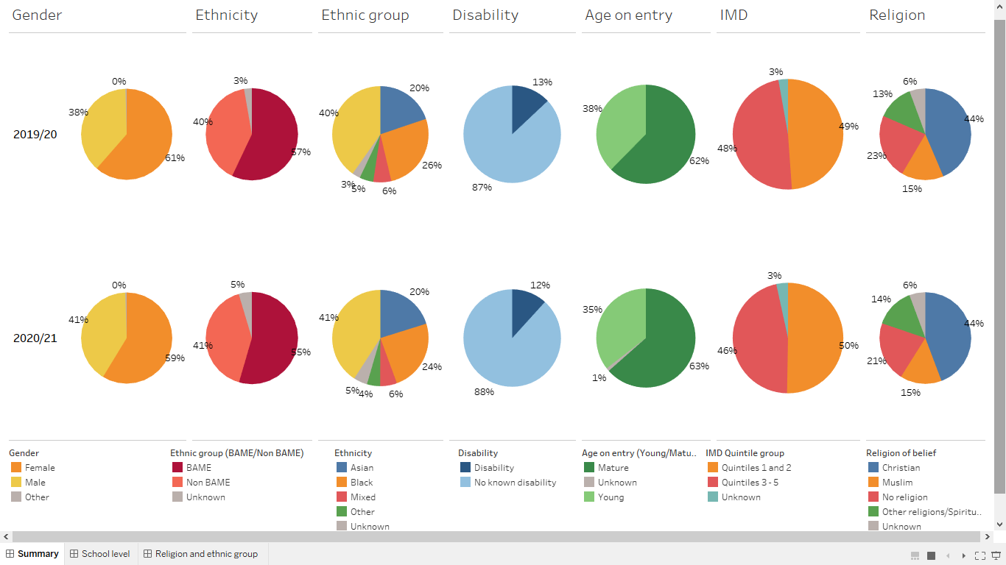
The charts below show student profiles by School
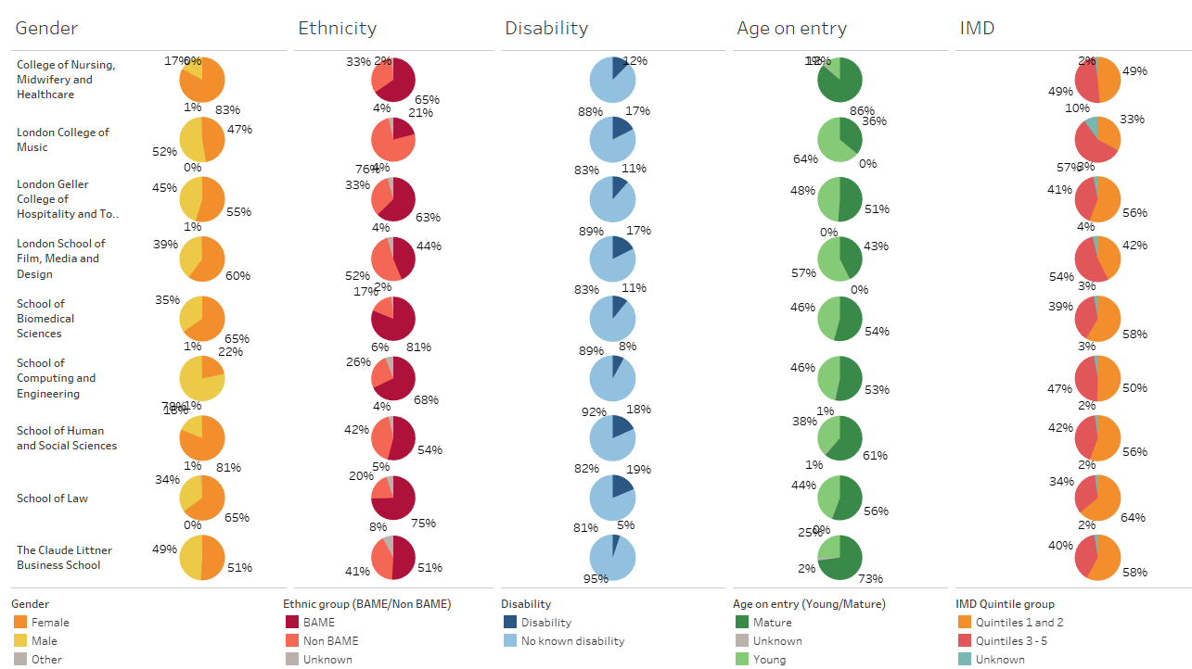

Staff Equality and Diversity Profile
2020/21

Author: Kevin West, Deputy Director of HR and Organisational Development

Summary

This paper describes the key equality and diversity characteristics of the University’s workforce.

Equality and Diversity

1. Gender

  - The University employs a higher number of female to male, at a ratio of 57:43, as shown in table 1 below. This proportion has remained consistent since the 2019/20 Academic Year and now places UWL above the sector average.

Table 1
Percentage of female in the workforce

Category | University of West London | Higher education average | Higher  education median
Academic staff | 50% | 49% | 50%
Managerial and professional staff | 54% | 52% | 54%
Support staff | 67% | 68% | 70%
All staff | 57% | 56% | 55%
Source: ResourceLink, 28 February 2021
DLA Piper Workforce Performance Indicators 2018

  - There are significant variations between schools, with female making up 23% of staff within the London College of Music compared to 65% in the School of Human and Social Sciences and 80% in the College of Nursing, Midwifery & Healthcare, as shown in chart 1 below.

Chart 1
Proportion of female employed by school

Source: ResourceLink, 28 February 2021

  - The percentage of females in the top earning group at the University is consistent with the sector average.

Chart 2
Percentage of top 5% of earners who are female

Source: ResourceLink, 28 February 2021
DLA Piper Workforce Performance Indicators 2018

Chart 3
Gender of associate professors and professors

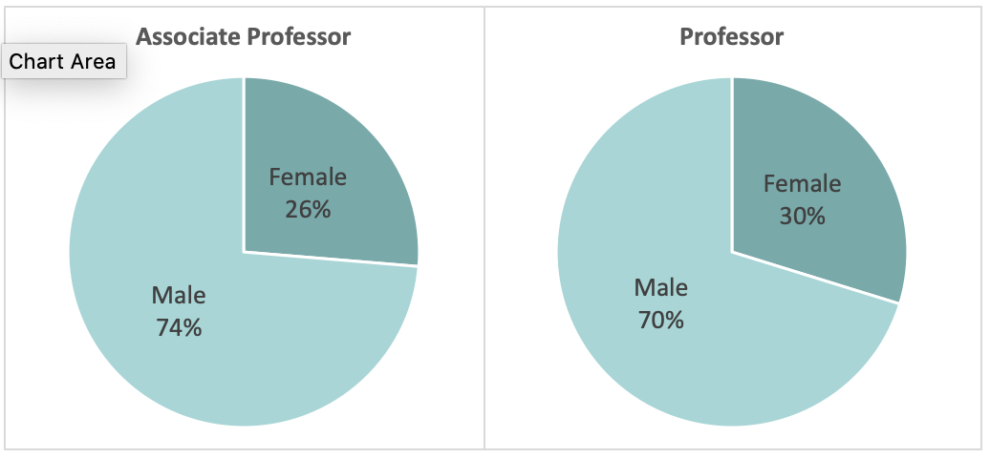

Category | Female | Male | Total
Associate Professor | 5 | 14 | 19
Professor | 14 | 33 | 47
Source: ResourceLink, 28 February 2021

Chart 4
Career family by gender

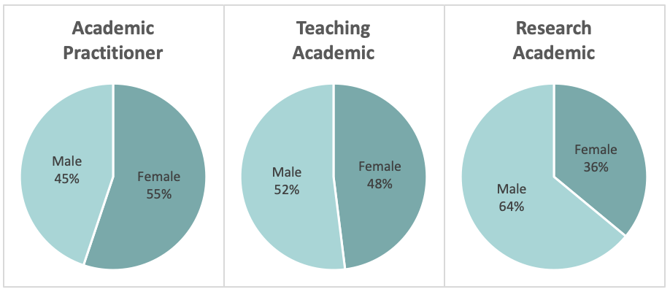
Source: ResourceLink, 28 February 2021

  - The focus of staff, and the allocation of time will vary within the different career families. For non-clinical academic staff the proportion of time spent in each of the three key areas is as follows:

Key area | Career family
 | Research academic (%) | Teaching academic (%) | Academic practitioner (%)
Teaching (maximum) | 33 | 60 | 90
Research, scholarship and knowledge exchange (minimum) | 33 | 10 | 5
Academic leadership and administration (remainder) | 33 | 30 | 5
Total | 100 | 100 | 100

2. Ethnicity

2.1 The proportion of permanent staff from black, Asian and minority ethnic groups (BAME) is 35%, which compares favourably with the higher education sector nationally, where 13% of staff are from BAME backgrounds, as shown in table 2 below. However, the BAME population in West London is between 35% and 45% and the percentage of academic staff from BAME backgrounds is 32%, compared to the university’s student population at 57%. 41% of hourly paid support staff and 28% of hourly paid lecturers are from BAME backgrounds.

Table 2
Percentage of permanent workforce who are from black Asian and minority ethnic groups
Category | University of West London | London Higher education average | Higher education average | Higher education median
Academic | 32% | 16.9% | 13% | 13%
Managerial & professional staff | 35% | 19.3% | 9% | 6%
Support staff | 39% | 27.7% | 13% | 8%
All staff | 35% | 22.4% | 13% | 10%
Source: ResourceLink, 28 February 2021
DLA Piper Workforce Performance Indicators 2018

Table 3
Percentage of academic workforce who are from BAME groups by school
School | Permanent staff | Hourly paid lecturers
College of Nursing, Midwifery & Healthcare | 34% | 18%
London College of Music | 2% | 12%
London School of Film, Media & Design | 14% | 16%
School of Biomedical Sciences | 39% | 0%
School of Computing & Engineering | 58% | 56%
School of Human and Social Sciences | 28% | 32%
School of Law | 40% | 50%
The Claude Littner Business School | 60% | 64%
The London Geller College of Hospitality & Tourism | 24% | 41%
All Schools | 32% | 28%
Source: ResourceLink, 28 February 2021

Chart 5
Ethnicity associate professors and professors

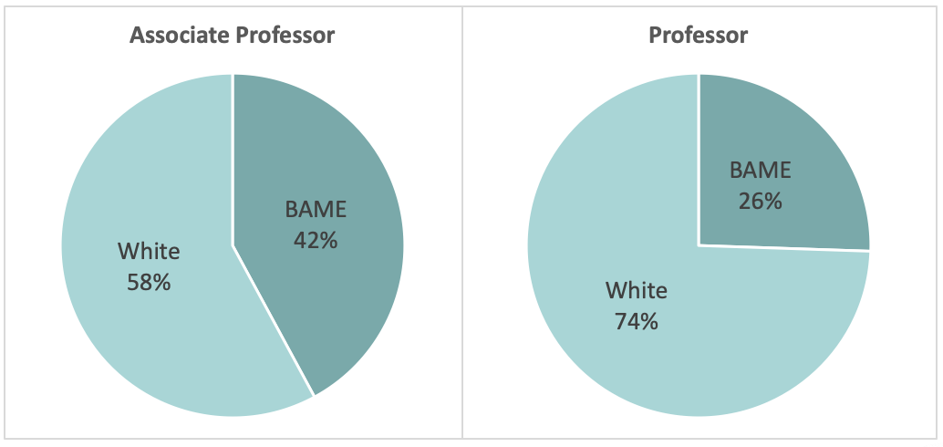

Category | BAME | White | Total
Associate Professor | 8 | 11 | 19
Professor | 12 | 35 | 47
Source: ResourceLink, 28 February 2021

3. Disability

3.2 The proportion of staff with a disclosed disability is low at 4.7%. Based upon the 2011 Census 14.2% of the London Borough of Ealing population state that they had a limiting long-term health problem or disability. 13.4% of the University’s student population have a declared disability.

Table 4
Percentage of workforce with a disability
Category | University of West London | London Higher education average | Higher education average | Higher education median
All staff | 4.7% | 5.5% | 5.2% | 5.0%
Source: ResourceLink, 28 February 2021
DLA Piper Workforce Performance Indicators 2018

- Age

  - The proportion of staff aged 55 and over has increased slightly during the past 12 months. However, as shown in chart 7, the proportion of academic staff aged 55 to 64 is higher than other Post 92 institutions. Overall, the percentage of staff in the age groups 25 to 34 has decreased during the past 12 months.

Chart 6
Age profile of workforce

Source: ResourceLink, 28 February 2021
DLA Piper Workforce Performance Indicators 2018

Chart 7
Age profile of academic workforce

Source: ResourceLink, 28 February 2021
DLA Piper Workforce Performance Indicators 2018

Chart 8
Age profile of managerial and professional staff

Source: ResourceLink, 28 February 2021
DLA Piper Workforce Performance Indicators 2018

Chart 9
Age profile of support staff

Source: ResourceLink, 28 February 2021
DLA Piper Workforce Performance Indicators 2018

- Religious Belief and Sexual Orientation

  - The number of staff having declared their religious belief and sexual orientation is now over 76% and the number of respondents continues to improve.

Chart 10
Religious belief

Source: ResourceLink, 28 February 2021

Chart 11
Sexual orientation

Source: ResourceLink, 28 February 2021

This is not a HESA data and may be subject to change

